CS 255 System Design Document

UML Diagrams

UML Use Case Diagram

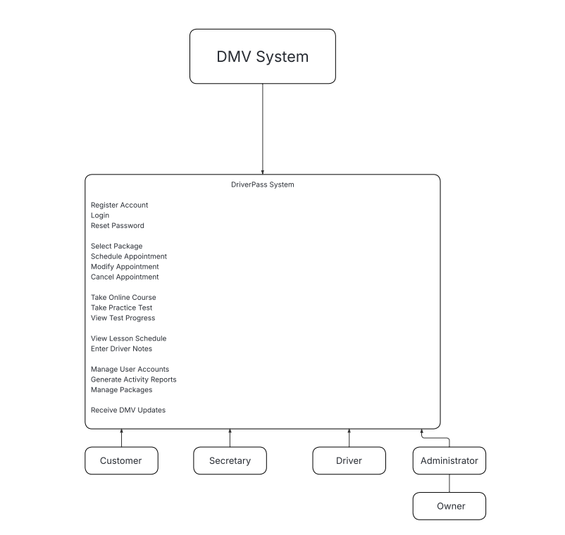

UML Activity Diagrams

Reserving Driving Lesson:

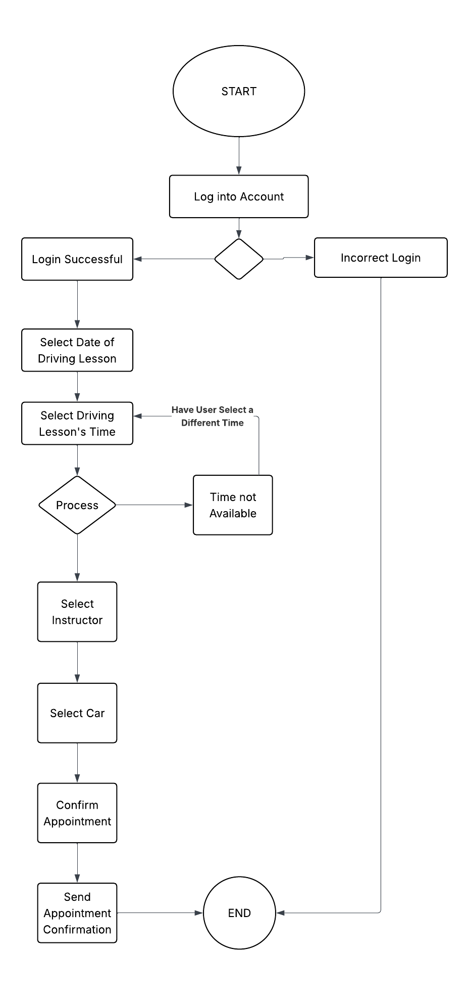

Registering Customer:

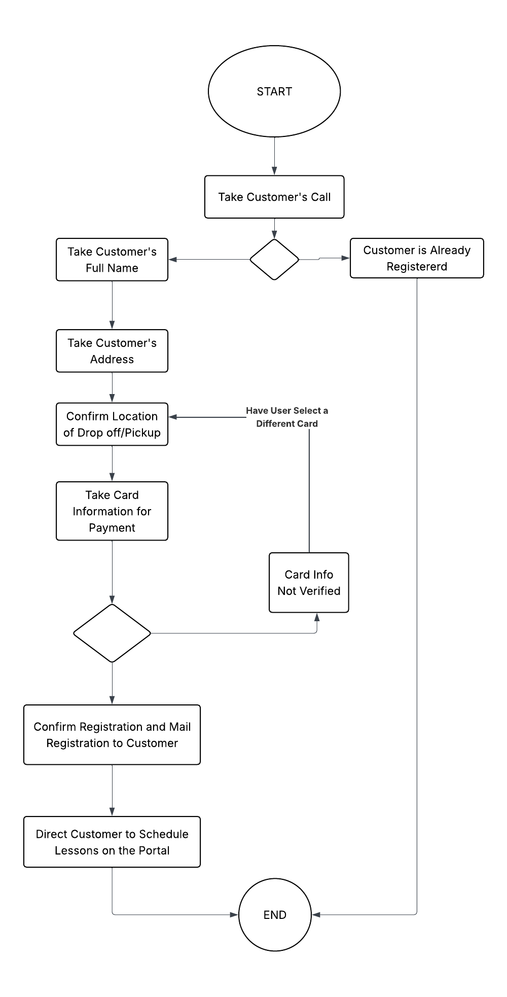

UML Sequence Diagram

Registering Customer:

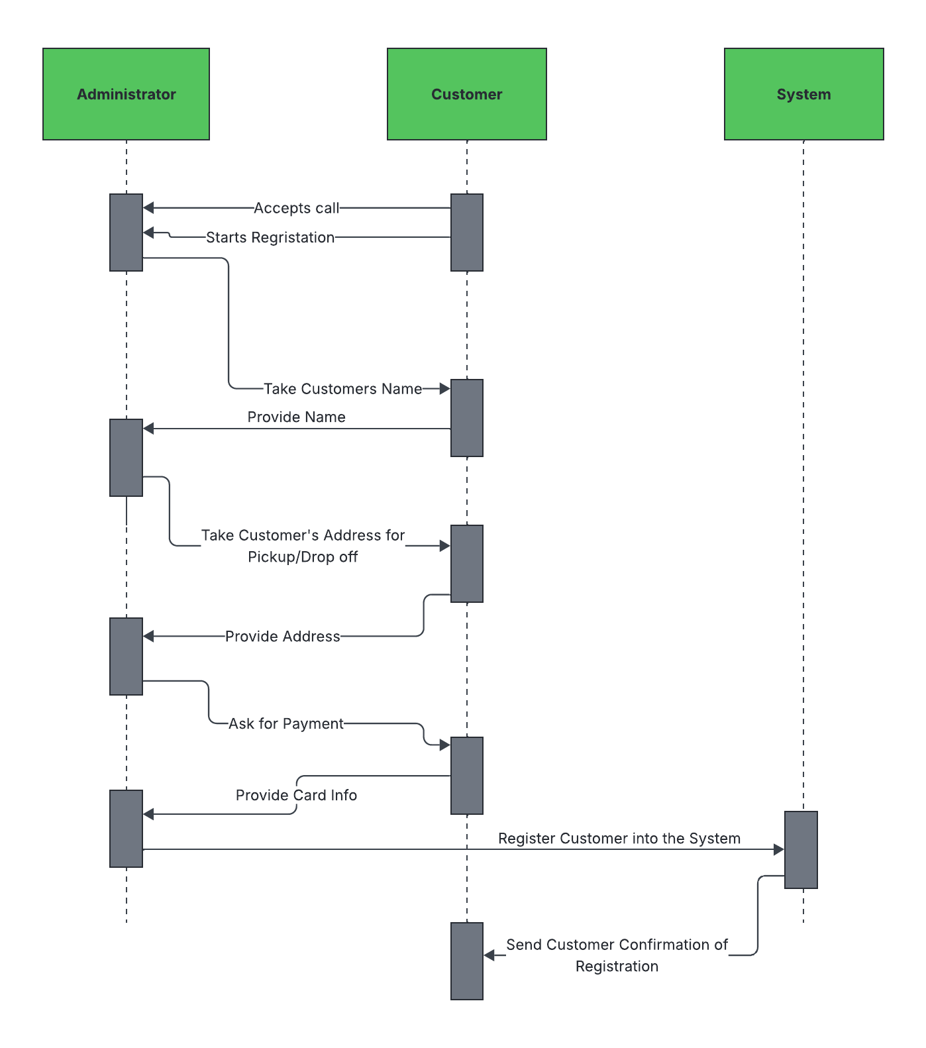

UML Class Diagram

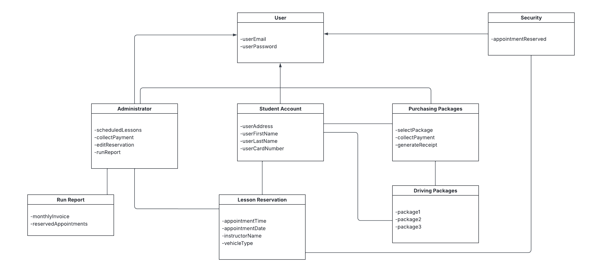

Technical Requirements
With this business being small, with opportunities for expanding, I recommend utilizing a cloud-based server for the cost-effective components/scalability. The computers should be provided for all members that are in the administration group with a Windows operating system. I would advise an automated back-up system to maintain secure information, like user information. This would also implement the security software to prevent any viruses which will be required. A reliable internet connection will be necessary for all administrators to receive the most up-to-date changes in reservations, schedules, or policies that have been submitted by the DMV. Accessing the DriverPass Web Portal will be available on operating systems that are commonly used, like Windows, MacOS, iOS, and Android devices to become easily accessible to a wide range of users.

